WHEN CLOUDS FAIL
Full-Color Figures & Diagrams
An Executive Playbook for Hybrid Sovereignty,
Multi-Cloud Resilience, and Agentic AI
by Steven Oppenheim
This companion document contains all 44 figures, diagrams, and visual frameworks from "When Clouds Fail" in full color for reference, presentation, and training use.
Order the book at Amazon or visit: whencloudsfail.opey.org
© 2026 Steven Oppenheim. All rights reserved.

Contents
Chapter 1: The New Reality
• The Modern Cloud Dependency Stack
Chapter 2: The Blast Radius Problem
• The Iron Triangle of Cloud Risk
• The 2025 Cloud Crisis Timeline
• The Cloud Outage Cascade Model
• The Automation Amplification Effect
• The AI Control Plane Risk
• The Abstraction Trap
Chapter 3: The Sovereignty Mandate
• The Sovereignty Ladder
• The Sovereignty Stack
• The Rent/Own Decision Matrix
• The Sovereign AI Reference Architecture
Chapter 4: The Sovereign Operating Model
• Identity as the Enterprise Root of Sovereignty
• The AI-Augmented Operating Gradient (L0-L5)
• The Resilience Triangle
• The Sovereign Cadence Model
• The CIO Financial Control Map
• The Sovereignty Toolkit Overview
• The Goldilocks Zone of Control
• The Decision Rights Architecture
• The Sovereign Architecture Compass
Chapter 5: Reference Architectures
• Hybrid Core Trade-off Matrix
• The Hybrid Core Sovereignty Stack
• Active/Active Multi-Cloud Reference Architecture
• The Sovereign AI Backbone Diagram
• The Cloud Exit & Failover Pattern
• Enterprise Failure Pattern Matrix
Chapter 6: Governance
• The Sovereign CIO Governance Map
• The Governance Stack Model
• The Compliance vs. Governance Translation Table
• Governance vs. Compliance Quick Reference
Chapter 7: Financial Models
• The Four Financial Lenses Framework
• The Four Lenses Detail View
• The 7-Year TCO Crossover Model
• The Resilience ROI Formula
• Hourly Outage Cost Formula Template
• Hourly Outage Cost Example
• The 90-Day Financial Sprint
• Financial Modeling Reference Card
Chapter 8: The Transformation Roadmap
• Three Transformation Failure Patterns
• The 12-36 Month Sovereign Roadmap
• Your First 90 Days Framework
Chapter 9: The Conclusion
• Three Paths to Sovereignty
Chapter 10: The Integrated CIO Operating Model
• Your Next 30 Days Action Plan
• The Sovereignty System (In One View)

CHAPTER 1
The New Reality
Figure 1: The Modern Cloud Dependency Stack
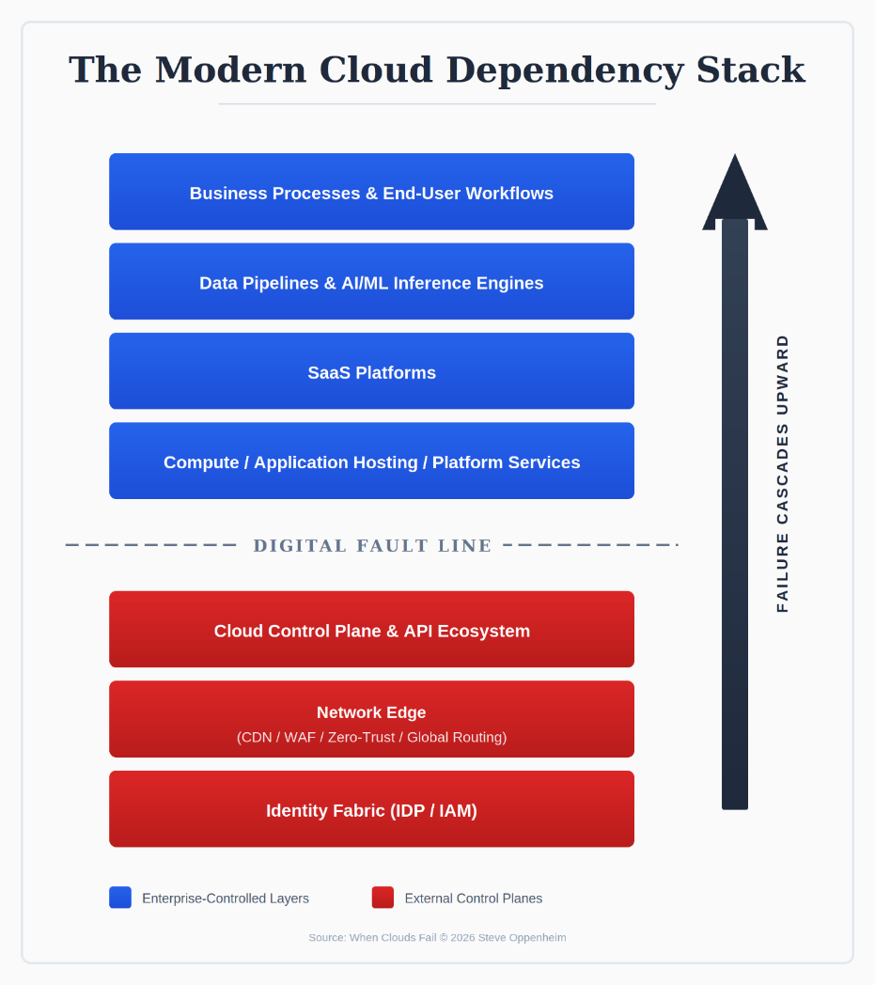
Seven-layer model showing the complete enterprise technology stack. Blue layers represent enterprise-controlled systems (Business Processes, Data Pipelines, SaaS, Compute). Red layers below the Digital Fault Line represent external control planes (Cloud Control Plane, Network Edge, Identity Fabric). The arrow shows how failures cascade upward from the foundation to business operations.

CHAPTER 2
The Blast Radius Problem
Figure 2: The Iron Triangle of Cloud Risk
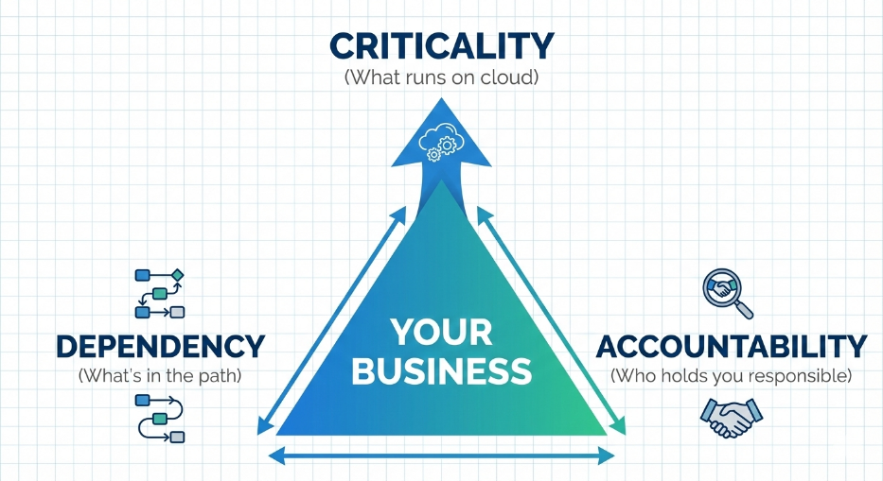
Three interconnected forces creating enterprise cloud risk: Criticality (what runs on cloud), Dependency (what's in the path), and Accountability (who holds you responsible). Your business sits at the center. Pull any vertex, and the other two tighten—this explains why cloud risk compounds faster than enterprises expect.

Figure 3: The 2025 Cloud Crisis Timeline
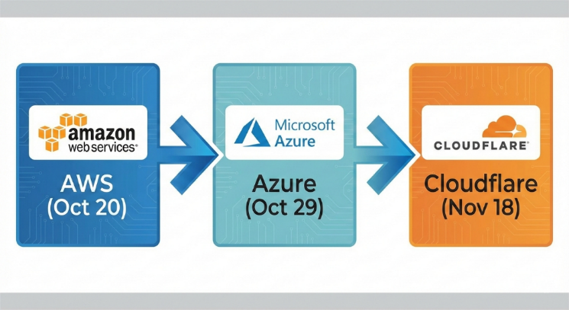
Back-to-back catastrophic cloud failures in late 2025: AWS US-EAST-1 (October 20), Microsoft Azure Front Door (October 29), and Cloudflare (November 18). This unprecedented cluster proved that hyperscaler failures are not isolated events but systemic patterns.
Figure 4: The Cloud Outage Cascade Model
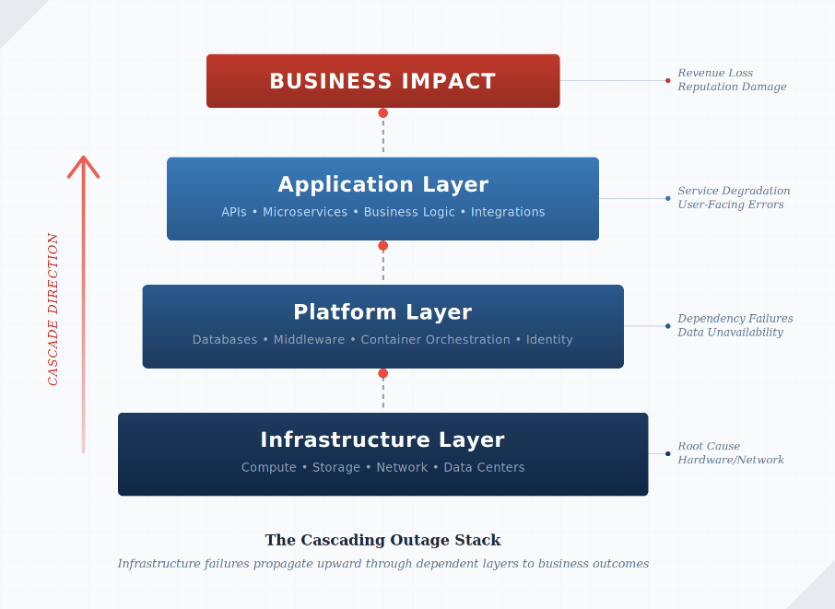
How a single infrastructure failure propagates through platform, application, and business layers. A networking glitch disrupts managed services, destabilizing applications and halting business operations. The same pattern repeats worldwide because enterprises share the same architectural assumptions.
Figure 5: The Automation Amplification Effect
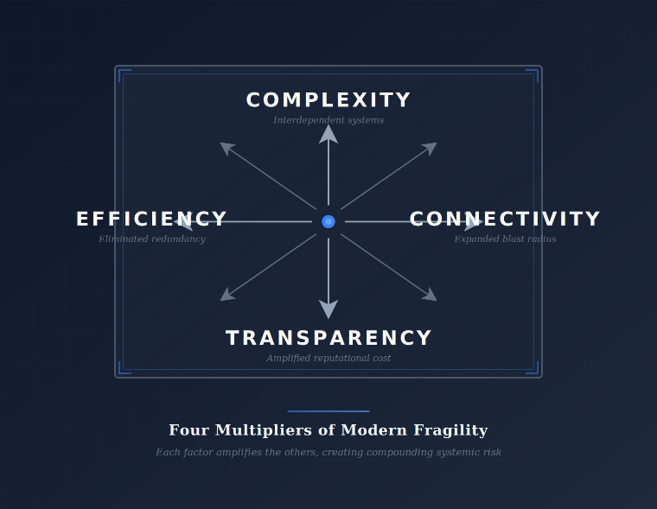
How modern automation and auto-scaling amplify failures rather than contain them. Like a high-speed lawnmower that can't distinguish grass from flower beds, automation propagates errors faster than humans can respond. The blast radius depends on propagation speed, not mistake size.

Figure 6: The AI Control Plane Risk
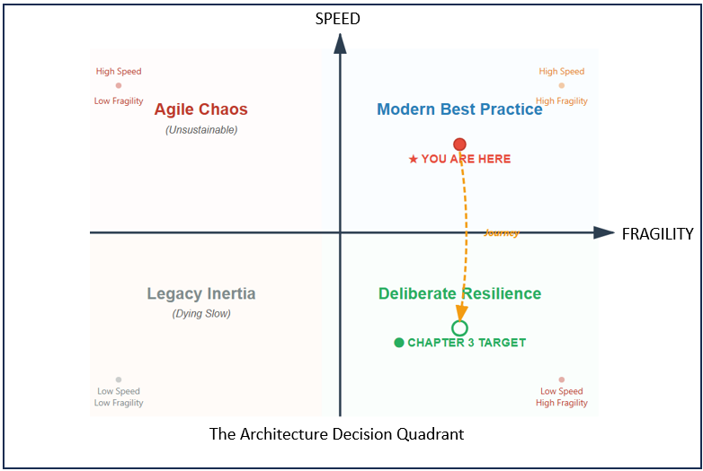
The new frontier of operational risk: AI-driven cloud control planes operating in state spaces too complex for human monitoring. Enterprises now fear the moment the cloud's AI decides something is broken when it isn't—and 'corrects' it across the entire platform.

Figure 7: The Abstraction Trap
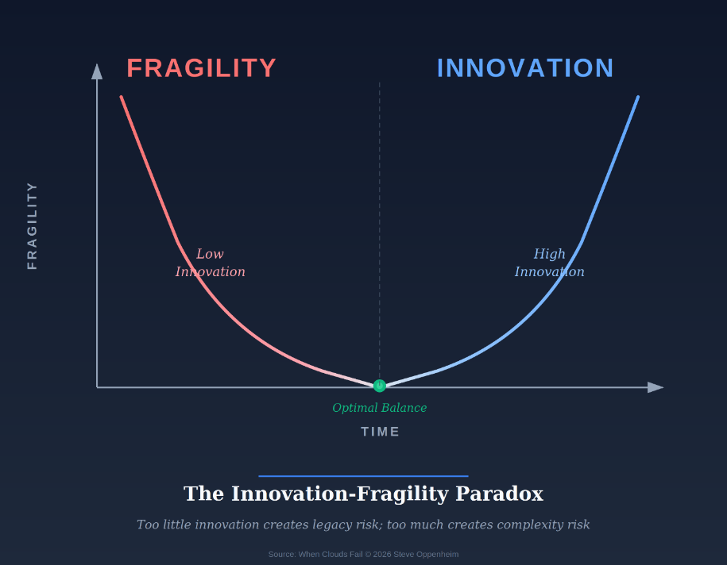
The Innovation-Fragility Paradox: each layer of abstraction (virtualization → containers → orchestration → managed services → AI) promises simplicity but surrenders visibility and control. Leaders mistake abstraction for safety, discovering their systems are most at risk when they understand them least.

CHAPTER 3
The Sovereignty Mandate
Figure 8: The Sovereignty Ladder
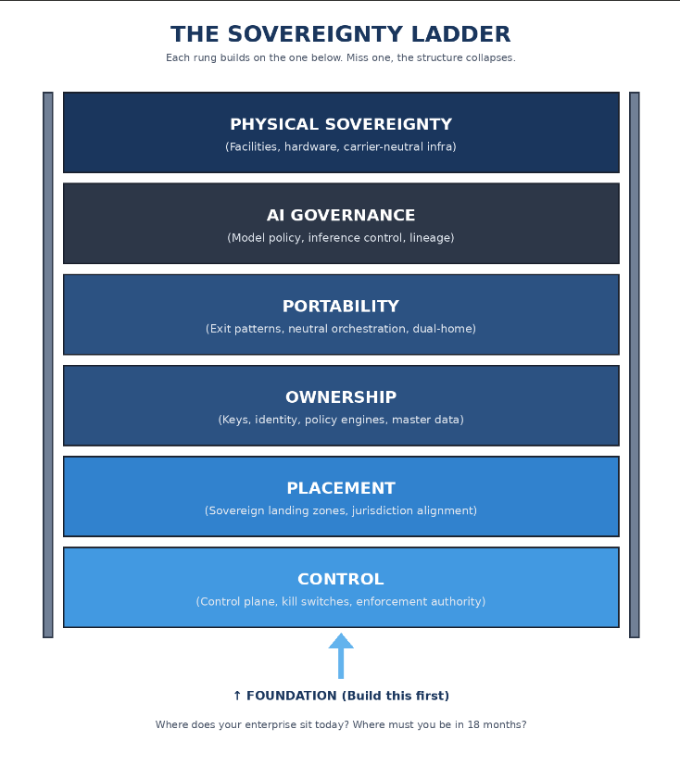
The six principles of Hybrid Sovereignty that define the CIO mandate for the decade ahead. This figure visualizes the sovereignty ladder: control → placement → governance → autonomy → authority → continuity. These principles anchor the operating doctrine for enterprises facing hyperscale outages and geopolitical fragmentation.

Figure 9: The Sovereignty Stack
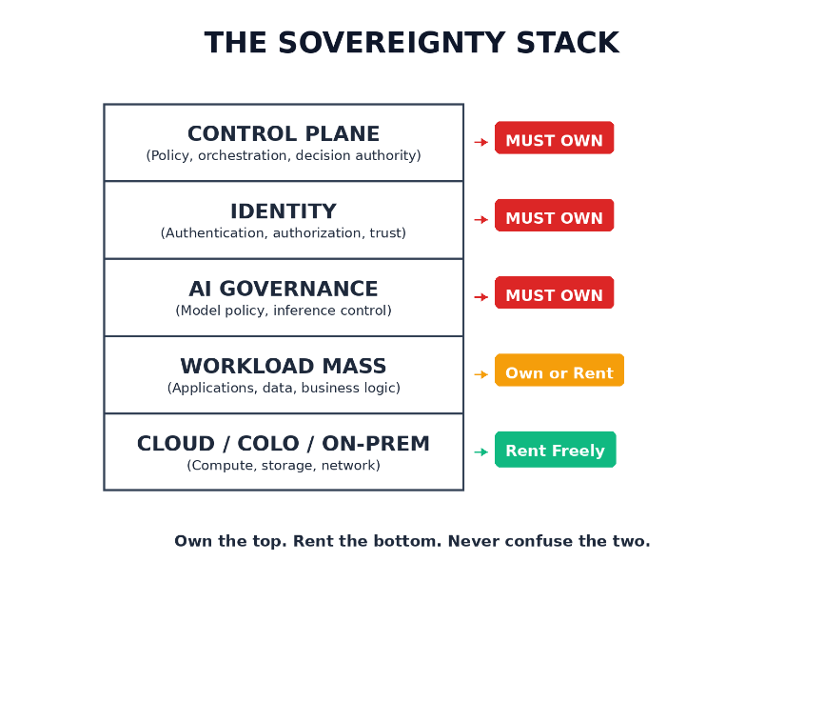
Non-negotiable hierarchy of ownership: Control Plane → Identity → AI Governance → Workload Mass → Cloud/Colo. This hierarchy is a map of power—if a cloud provider owns any layer, the provider commands your operational fate. Dependency becomes policy; continuity becomes conditional.

Figure 10: The Rent/Own Decision Matrix
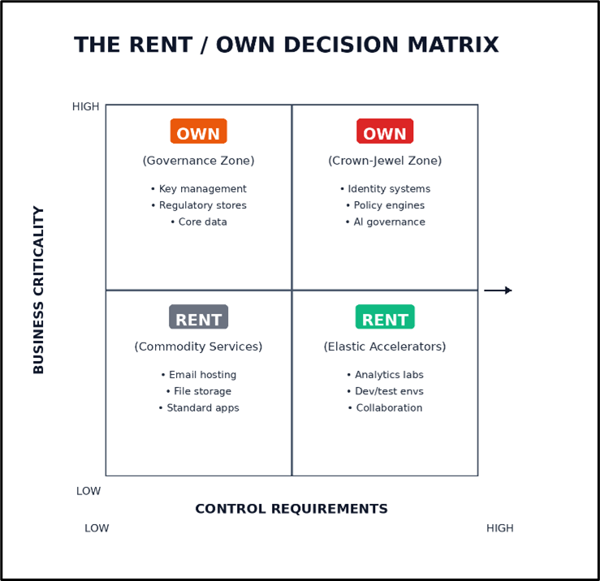
A 2×2 framework converting cloud strategy from improvisation into doctrine. Determines what enterprises must own (governance, keys, policy engines, data behaviors) versus what they can safely rent. Without this distinction, cloud adoption becomes accidental outsourcing of functions no enterprise can afford to delegate.

Figure 11: The Sovereign AI Reference Architecture
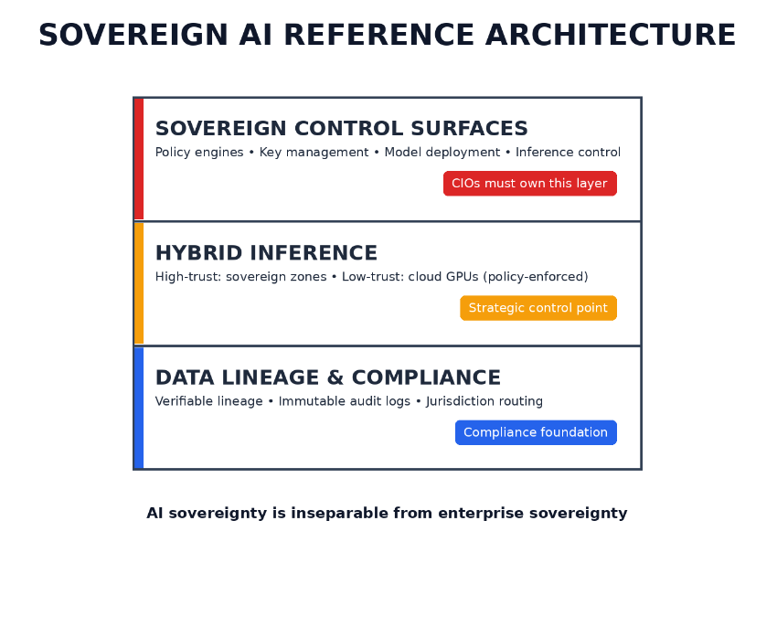
Three architectural layers CIOs must govern for AI sovereignty: the model layer (selection, fine-tuning, versioning), the inference layer (where decisions execute), and the data layer (training data lineage and boundaries). CIOs who cannot demonstrate AI sovereignty face regulators, litigation, and reputational damage.

CHAPTER 4
The Sovereign Operating Model
Figure 12: Identity as the Enterprise Root of Sovereignty
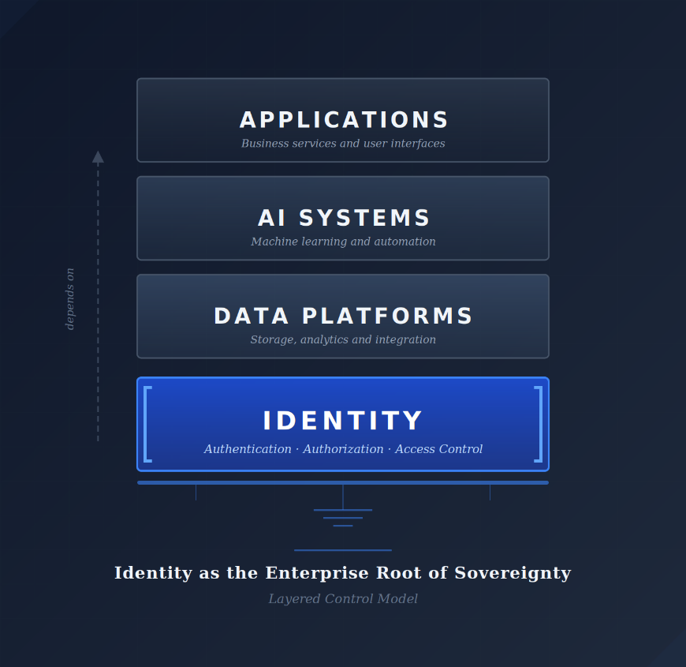
Identity as the load-bearing foundation beneath Applications, AI Systems, and Data Platforms. Every higher-order capability derives from authenticated, authorized, continuously verified trust. If identity fractures, the entire sovereignty stack becomes non-sovereign, even when cloud regions remain healthy.

Figure 13: The AI-Augmented Operating Gradient (L0-L5)
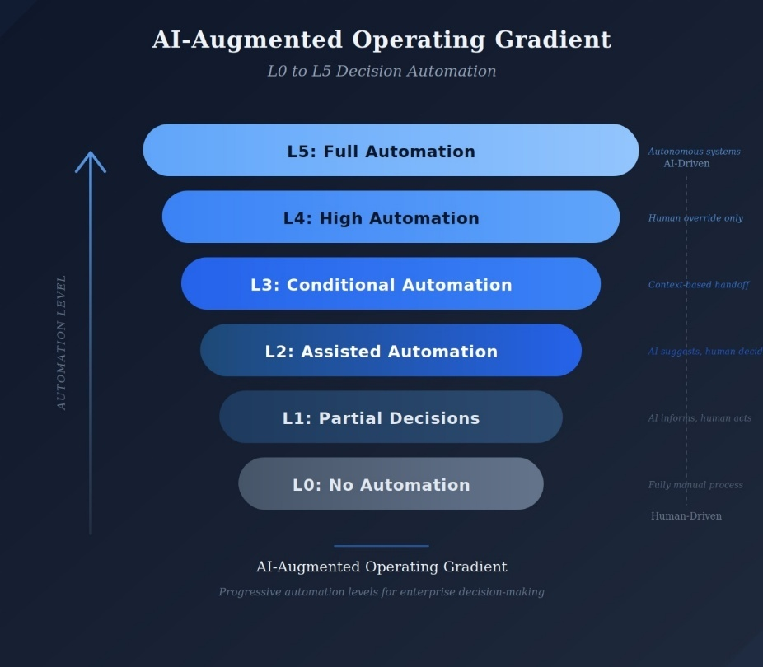
Progressive automation levels from L0 (No Automation/Human-Driven) to L5 (Full Automation/AI-Driven). Defines the boundaries of AI authority—what AI can decide, what guardrails constrain it, and when humans shift from in-the-loop to on-the-loop. Many enterprises already operate at L3-L4 without realizing it.

Figure 14: The Resilience Triangle
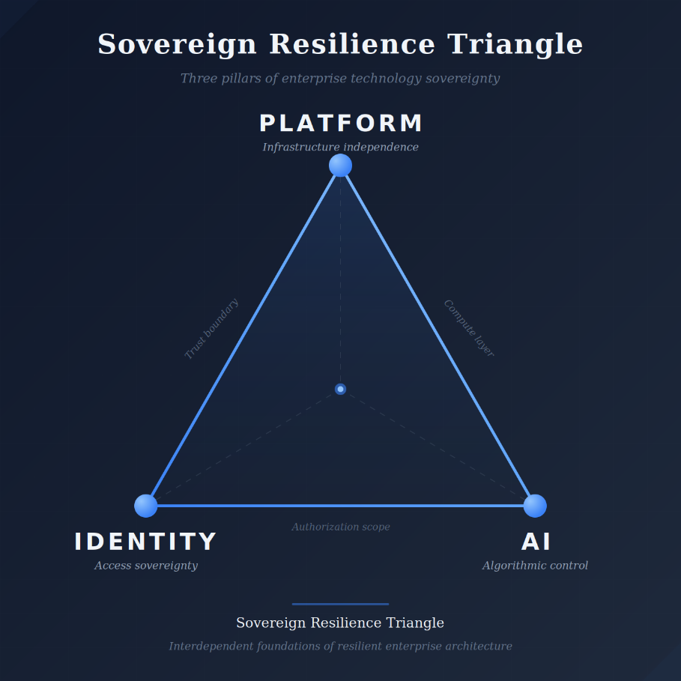
How architecture sovereignty, identity sovereignty, and AI sovereignty combine to create operational resilience. If any corner weakens, the whole enterprise becomes non-resilient. Modern resilience demands: multi-cloud, multi-region, identity-isolated, provider-independent, data-portable, AI-governed infrastructure.

Figure 15: The Sovereign Cadence Model
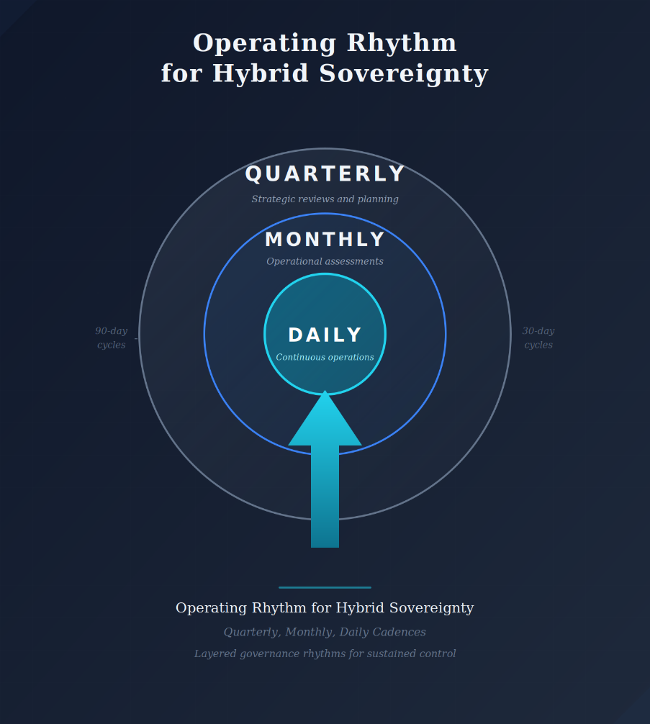
The operating rhythm that sustains sovereignty: quarterly cycles for architectural alignment, monthly cycles for drift detection and identity boundary correction, daily cycles for real-time monitoring. CIOs who treat sovereignty as a one-time strategy always lose it; those who run it as a cycle never do.

Figure 16: The CIO Financial Control Map
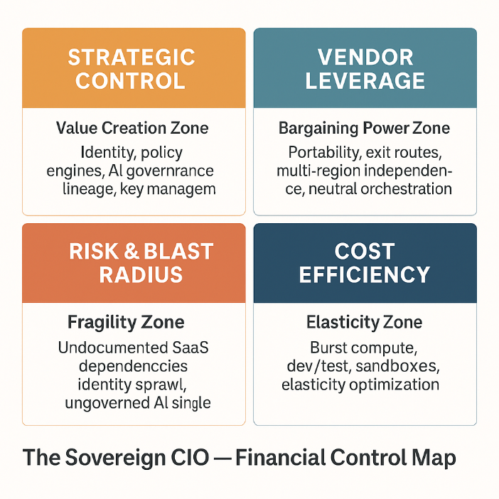
Economic blueprint showing where every dollar creates strength versus leaks into dependency. Breaks sovereignty economics into four dimensions, showing where hidden fragility accumulates. The CIO must own not only the architecture but the economics beneath it.

Figure 17: The Sovereignty Toolkit Overview
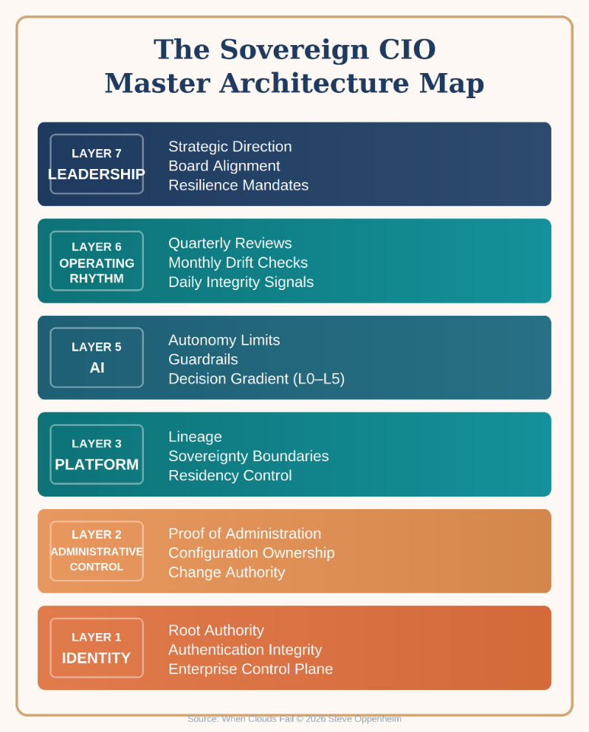
Four integrated tools that turn sovereignty from aspiration into an operating system: The 90-Day Plan (establishes sovereignty), Cadence Model (sustains it), Anti-Patterns (reveal decay), and 4-R Framework (guides trade-off decisions). Together, they create a living system run by people and reinforced by rhythm.

Figure 18: The Goldilocks Zone of Control
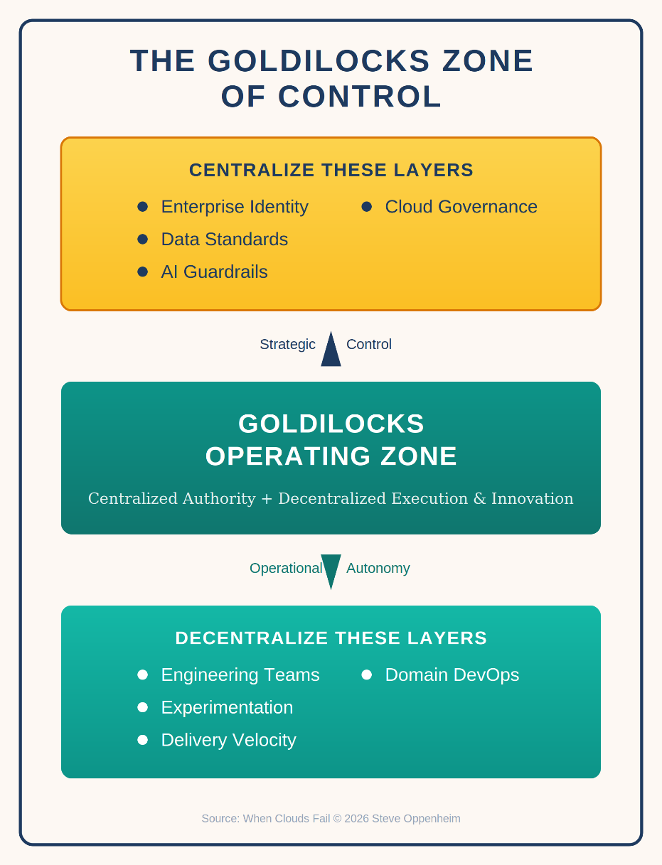
Maps the operational sweet spot between centralization and decentralization. Identity, cloud governance, AI governance, and data standards must be centralized. Engineering, execution, and experimentation should be decentralized. This balance protects sovereignty without killing velocity.

Figure 19: The Decision Rights Architecture
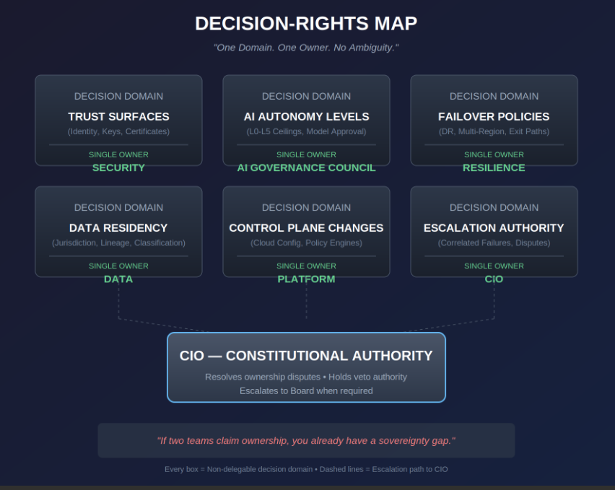
Constitutional map of who controls platforms, data, AI, identity, and resilience. When everyone influences a decision but no one owns it, chaos emerges. This governance instrument clarifies ownership and prevents the political failures that doom sovereignty programs.

Figure 20: The Sovereign Architecture Compass
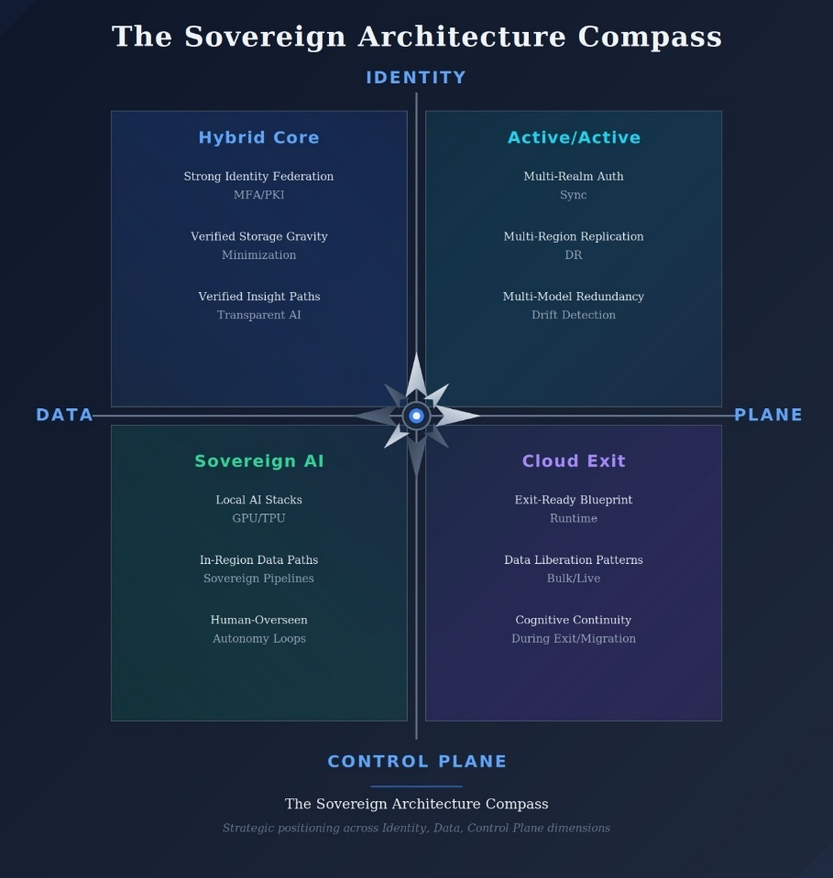
Maps the four sovereignty backbones (Hybrid Core, Active/Active, Sovereign AI, Cloud Exit) to four existential failure domains (identity, data, cognition, control-plane integrity). The first model to treat cloud, AI, identity, and control plane as a single dependency fabric.

CHAPTER 5
Reference Architectures
Figure 21: Hybrid Core Trade-off Matrix
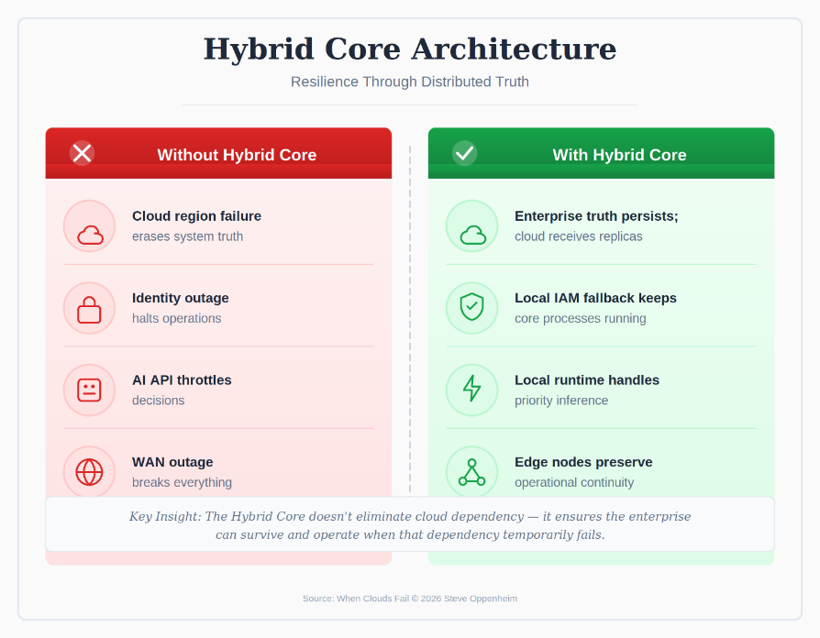
Every architectural choice in Hybrid Sovereignty comes with a trade-off. This matrix maps the decisions Rebecca's team made: what to keep on-premise, what to federate, and what to accept as cloud-dependent. Hybrid Core becomes real when you know exactly what you refuse to lose control over.

Figure 22: The Hybrid Core Sovereignty Stack
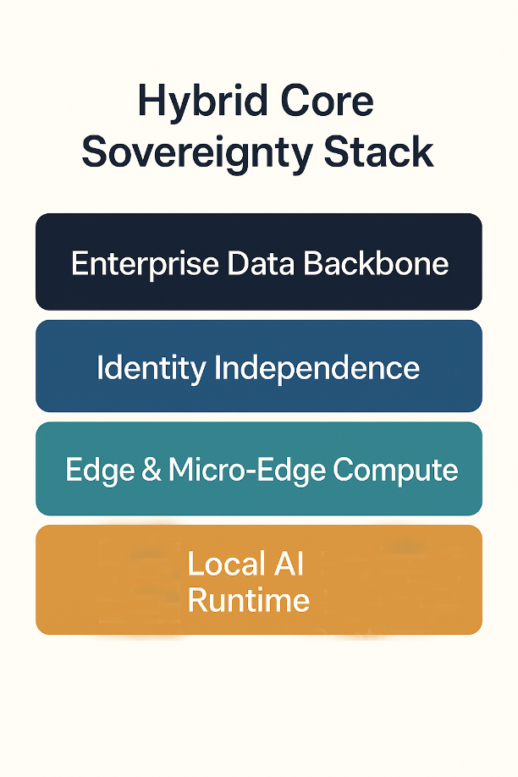
Four stacked layers showing who still stands when the cloud region fails: Local AI Runtime (bottom), Edge & Micro-Edge Compute, Identity Independence, and Enterprise Data Backbone (top). These layers survived when 89 cloud-native dependencies had to be refactored into sovereign patterns.

Figure 23: Active/Active Multi-Cloud Reference Architecture
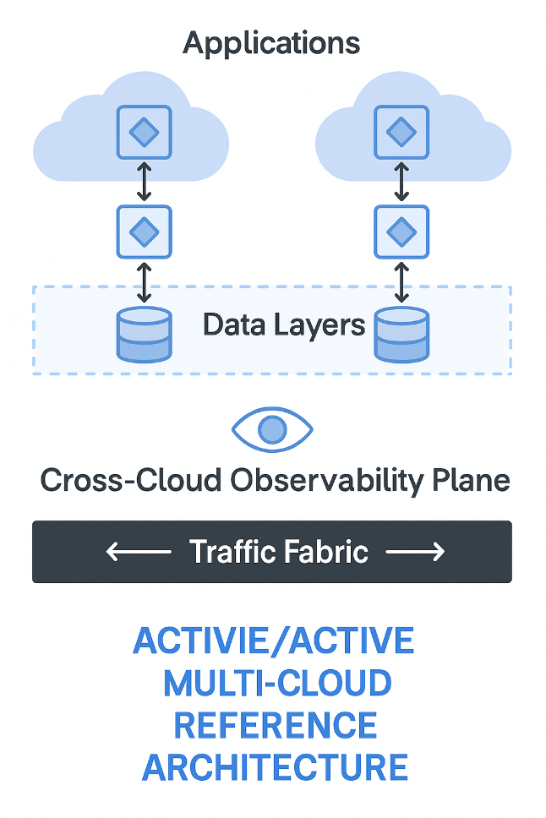
How to erase hyperscaler concentration as a single point of failure. Shows applications running across two clouds with shared Data Layers, Cross-Cloud Observability Plane, and Traffic Fabric. Active/Active only works when truth itself is portable—2,700 enterprises learned this when centralized identity failed both their clouds.

Figure 24: The Sovereign AI Backbone Diagram
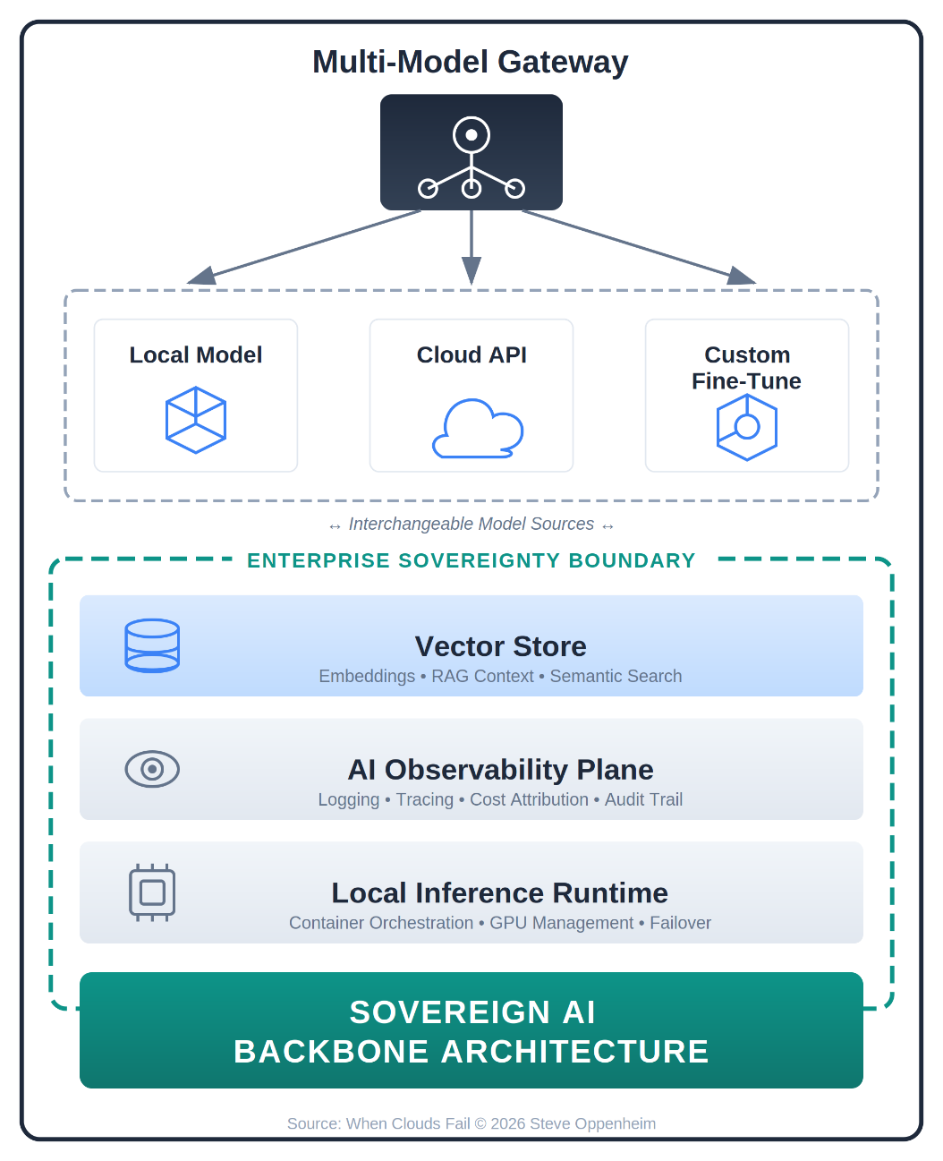
A multi-model gateway architecture that ensures intelligence remains online when providers fail. Shows gateway routing to local models, cloud APIs, and internal fine-tunes, with a vector memory layer, AI observability plane, and a local inference runtime beneath. Use this to explain why your AI strategy doesn't collapse when a single provider changes terms.

Figure 25: The Cloud Exit & Failover Pattern
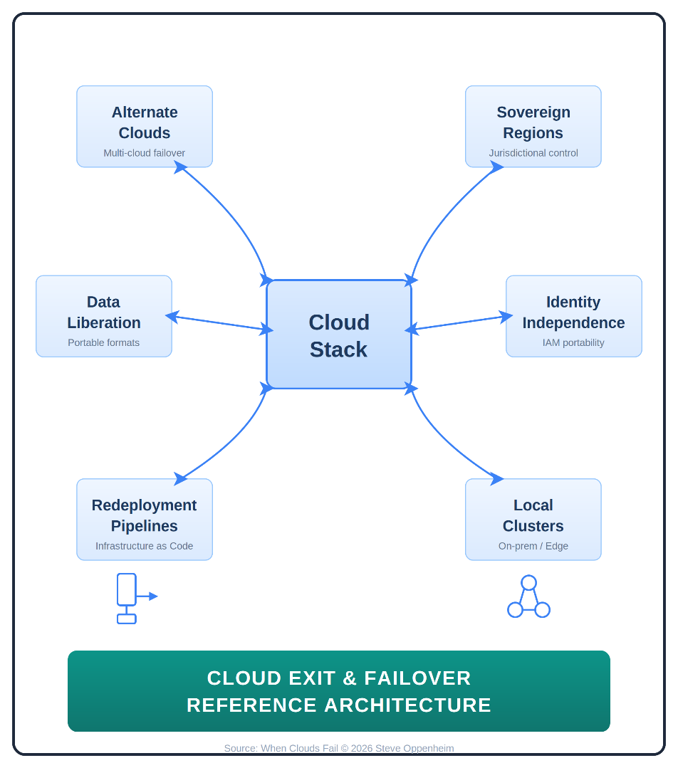
Four pillars of exit readiness: Data Liberation, Identity Independence, Redeployment Pipelines, and Dependency Mapping. The truth test for portability claims—if you cannot point to all four pillars without hesitation, you cannot exit. Most enterprises have never exercised this muscle.

Figure 26: Enterprise Failure Pattern Matrix
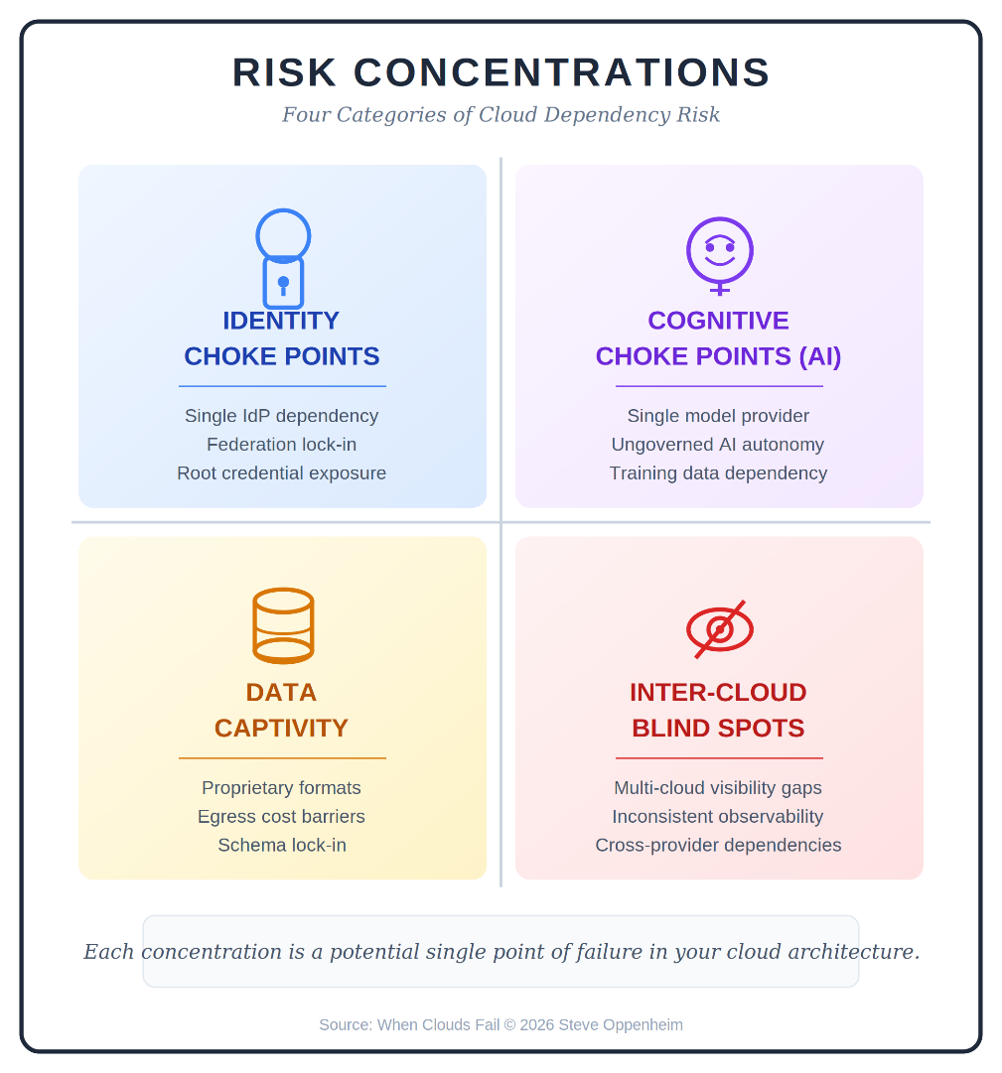
Four recurring failure patterns across global outages: identity choke points, cognitive choke points (AI), data captivity, and inter-cloud blind spots. Every case study maps to one of these patterns, proving failures are predictable—and preventable. Use as sanity check for your roadmap.

CHAPTER 6
Governance
Figure 27: The Sovereign CIO Governance Map
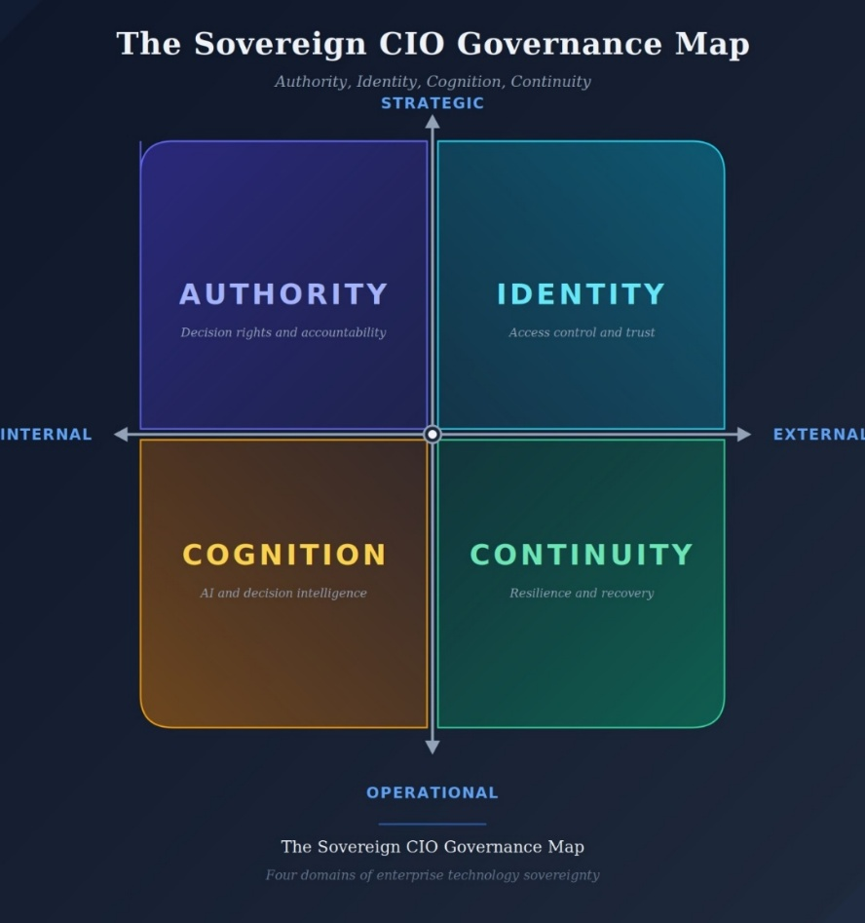
Four governance domains on Strategic/Operational and Internal/External axes: Authority (decision rights), Identity (access control), Cognition (AI governance), and Continuity (resilience). Every major failure—cloud outage, AI misfire, identity cascade, regulatory shock—attacks one or more domains.

Figure 28: The Governance Stack Model
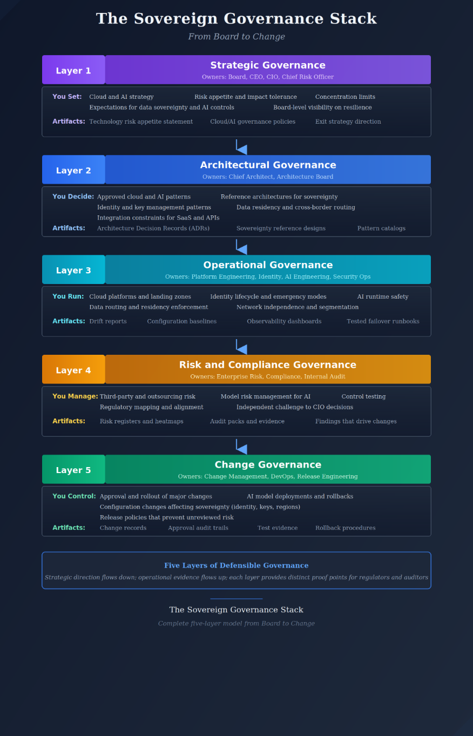
Multi-layer governance showing how Rebecca traced decisions top-down in 2 hours 43 minutes during an FCA inquiry. Each layer—Strategic, Domain, Operational, Evidence—defines who approves, operates, challenges, and records. The stack isn't an org chart; it's a decision tree you traverse while the clock runs.

Figure 29: The Compliance vs. Governance Translation Table
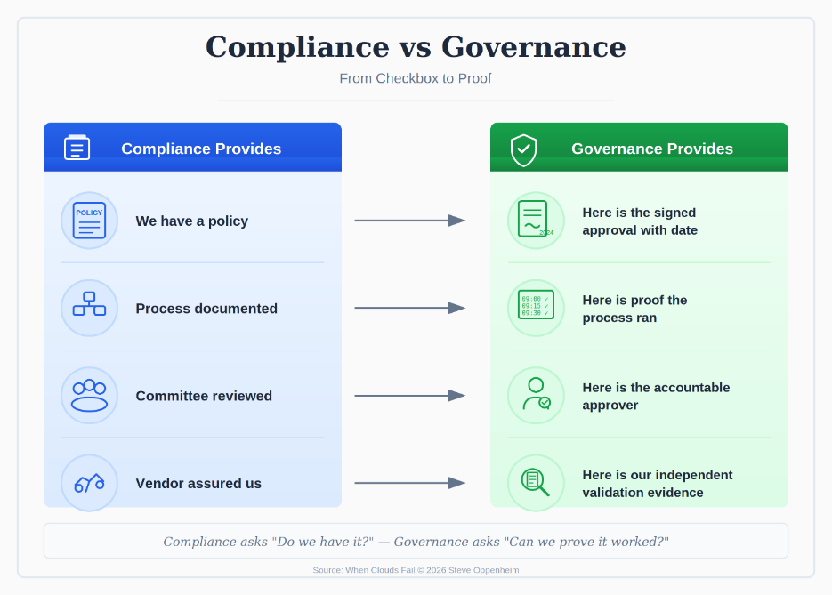
Side-by-side comparison: Compliance tells you what rules exist; Governance proves you followed them under pressure. Compliance produces policies and frameworks; Governance produces named approvals, decision records, dates, signatures, and test evidence. When hard questions arrive, proof keeps leaders employed.

Figure 30: Governance vs. Compliance Quick Reference
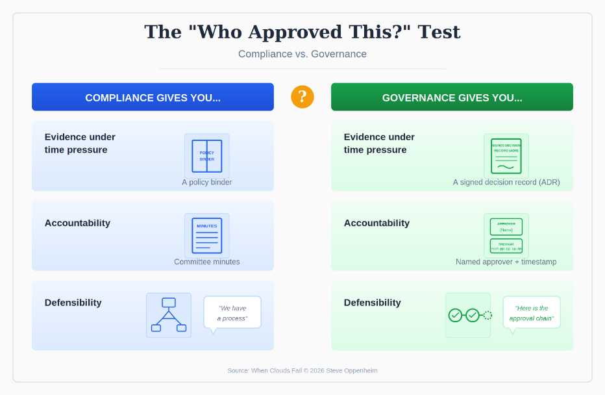
The shortcut: Compliance describes what should happen; Governance proves what did happen. If your governance artifacts cannot be produced fast, they do not exist. Board-ready reference card for distinguishing documentation from evidence.

CHAPTER 7
Financial Models
Figure 31: The Four Financial Lenses Framework
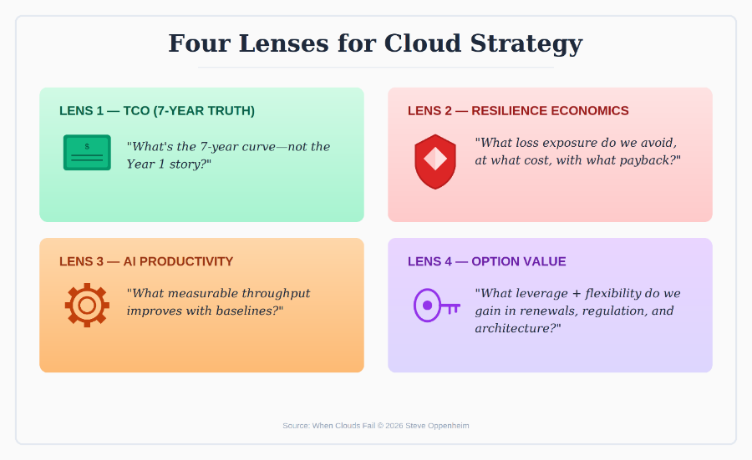
Four lenses that separate weak business cases from board-level weapons: Cost Optimization (7-year TCO), Risk Reduction (failure cost), Productivity/AI Multipliers (efficiency gains), and Option Value (strategic flexibility). When all four align, the argument becomes almost impossible to reject.

Figure 32: The Four Lenses Detail View
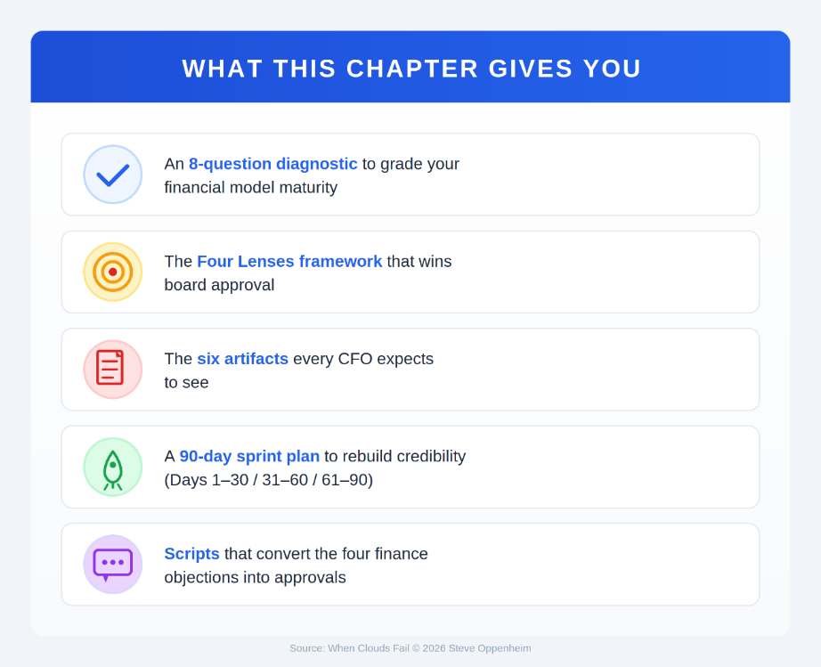
Questions each lens answers: Top-left forces discipline (what do we spend over 7 years?). Top-right reframes risk (what does failure cost?). Bottom-left quantifies AI (how many hours do we improve?). Bottom-right captures leverage (what strategic advantage do we gain?). Most failed business cases show only top-left.

Figure 33: The 7-Year TCO Crossover Model
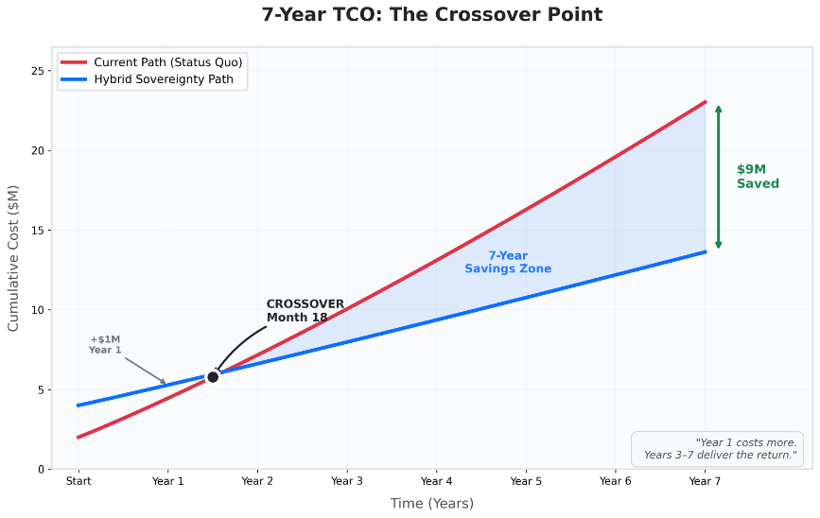
Shows how the business case 'looks expensive' only until the crossover month—after that, the status quo becomes the high-cost option permanently. Complete the TCO model forces estimation for variables that explode after migration: data movement, AI growth, managed service creep, and governance overhead.

Figure 34: The Resilience ROI Formula
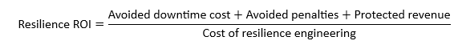
Components boards expect to see modeled: revenue loss per hour, contractual penalties, churn impact, brand damage, regulatory sanctions, recovery labor. Transform 'Active/active is expensive' into 'Active/active returns 3:1 on avoided losses.'
Figure 35: Hourly Outage Cost Formula Template
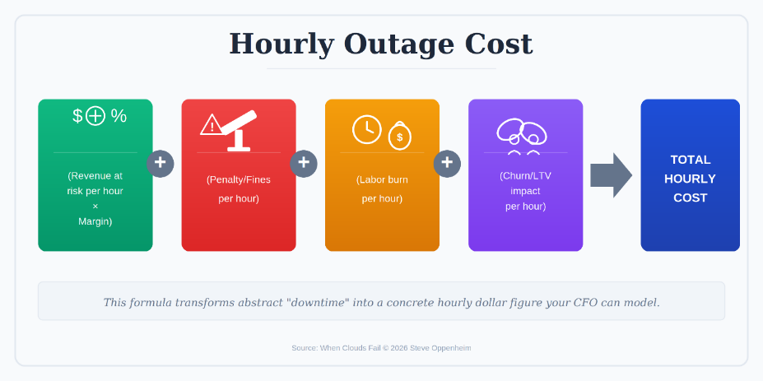
Copy this template to calculate per-service outage costs using a defensible methodology. Simple formula that CFOs can audit: revenue impact + labor cost + penalty exposure + reputation factor = hourly cost per service.

Figure 36: Hourly Outage Cost Example
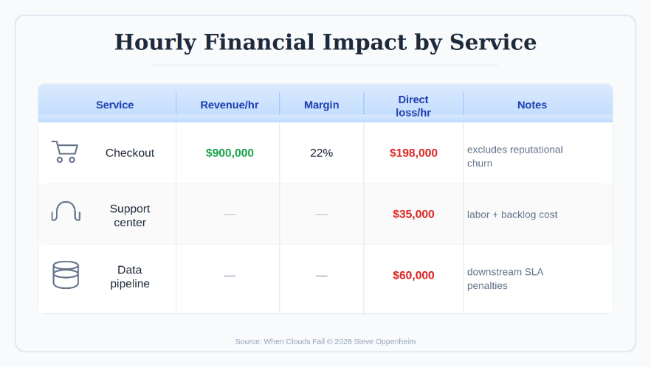
Worked example with illustrative numbers showing the outage cost calculation in practice. Replace this data with your own to produce board-ready cost estimates. Annual exposure = Hourly outage cost × Expected incident hours per year.

Figure 37: The 90-Day Financial Sprint
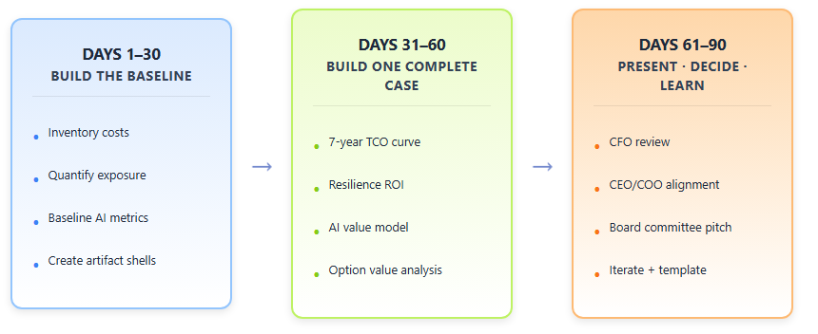
Three-phase sprint that builds financial credibility: Days 1-30 (Build Baseline), Days 31-60 (Model Scenarios), Days 61-90 (Produce Artifacts). Repeatable models build credibility once; sprints make it permanent. The system that turned finance from skeptic to partner.
Figure 38: Financial Modeling Reference Card
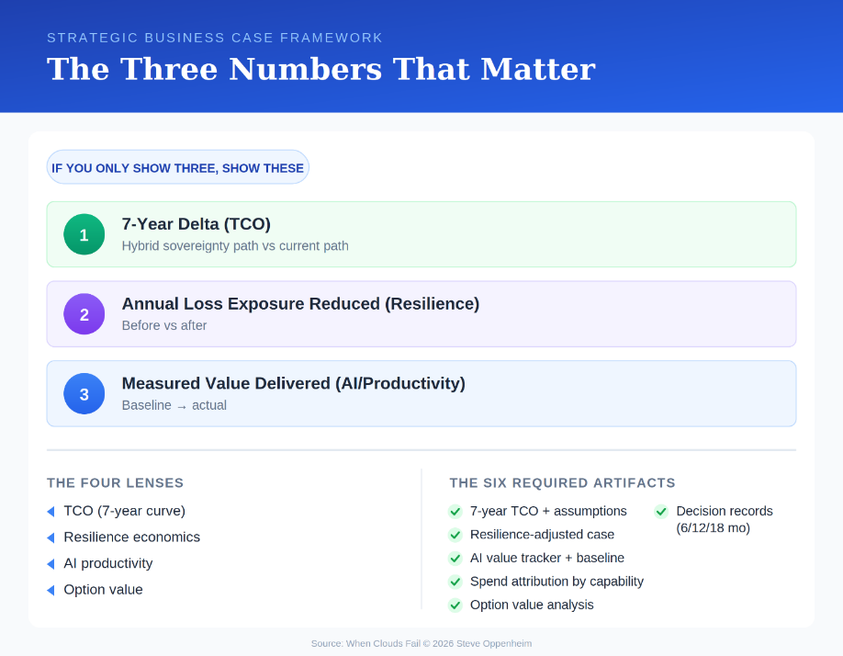
Board-ready summary for budget reviews. Four dimensions boards evaluate, five red flags boards punish, and the four objection patterns (time horizon, magnitude, framing, measurement). Use the Four Lenses, show the math, produce artifacts. Objections become approvals.

CHAPTER 8
The Transformation Roadmap
Figure 39: Three Transformation Failure Patterns
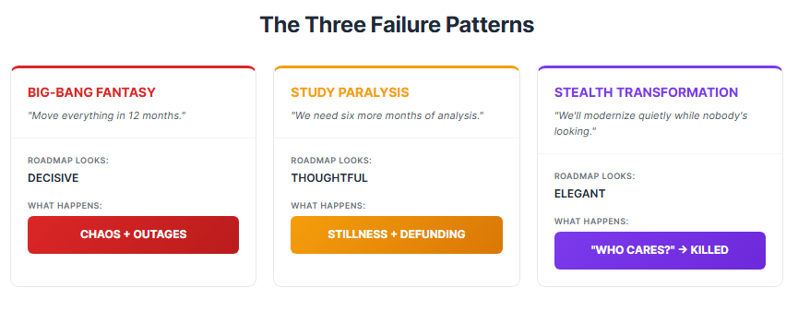
Most sovereign transformations fail in three predictable ways—none because leaders lacked intelligence. Pattern 1: Overcommitment (promising more than capability allows). Pattern 2: Under-communication (going silent then returning with bad news). Pattern 3: Political capture (program becomes a battleground). Diagnose before you launch.

Figure 40: The 12-36 Month Sovereign Roadmap
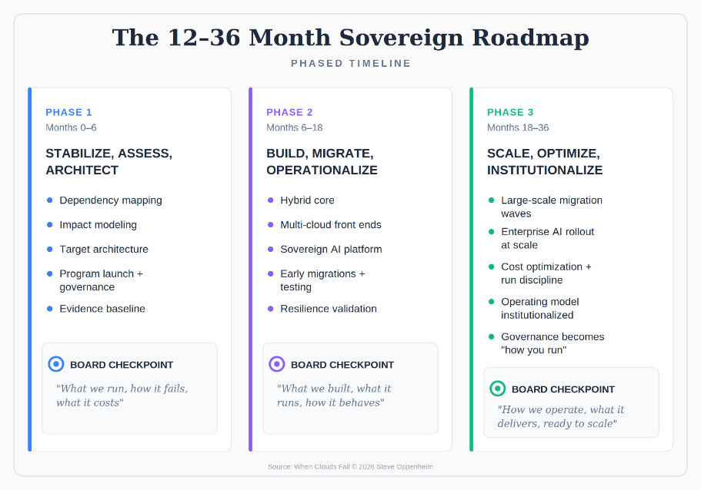
Board-credible roadmap showing phases, decision gates, and quarterly trust deposits—not just tasks and dates. The roadmap approved in 18 minutes because it was honest: 'We're tired of being lied to by optimism. We'll take the plan that works.'

Figure 41: Your First 90 Days Framework
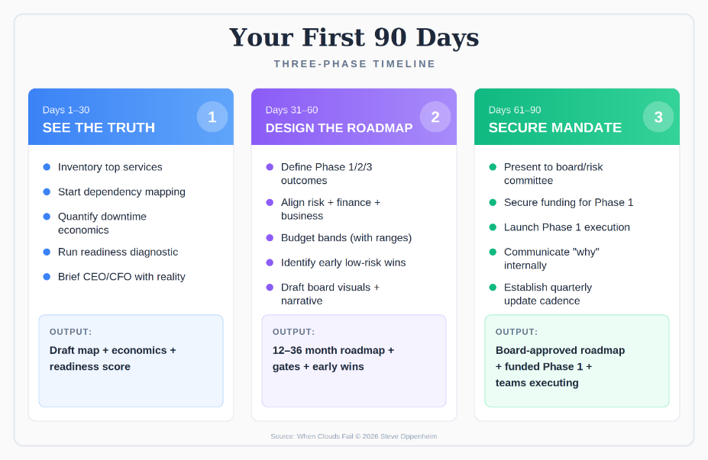
You don't need to finish the transformation in 90 days—you need to make it irreversible. Concrete milestones that establish momentum, build board confidence, and create the foundation that prevents program cancellation.

CHAPTER 9
The Conclusion
Figure 42: Three Paths to Sovereignty
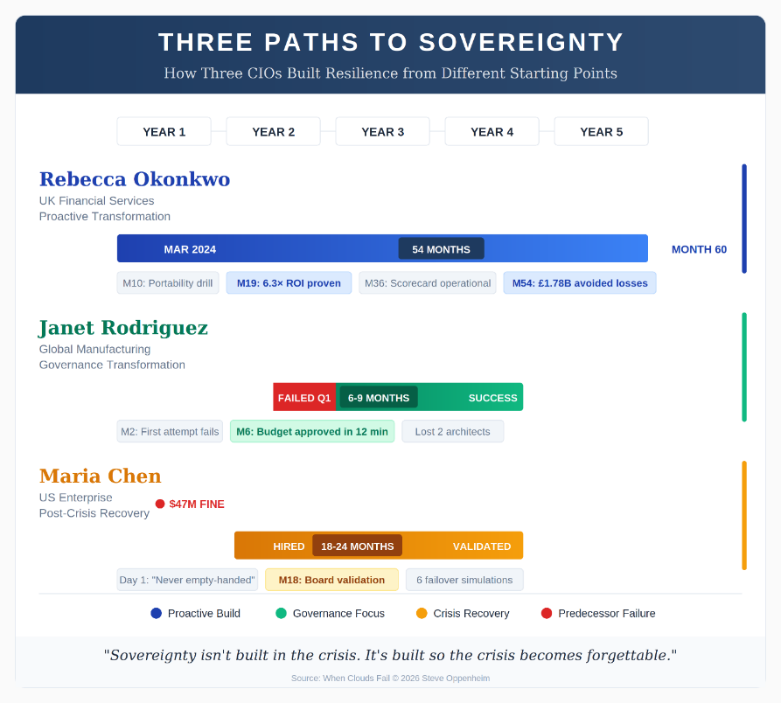
Three CIO journeys converging on sovereignty: Rebecca Okonkwo's proactive 54-month arc (6.3× ROI, £1.78B avoided losses), Janet Rodriguez's 6-month governance transformation (budget approved in 12 minutes), and Maria Chen's 18-month post-crisis recovery. The question isn't which path is right—it's which matches where you stand today.

CHAPTER 10
The Integrated CIO Operating Model
Figure 43: Your Next 30 Days Action Plan
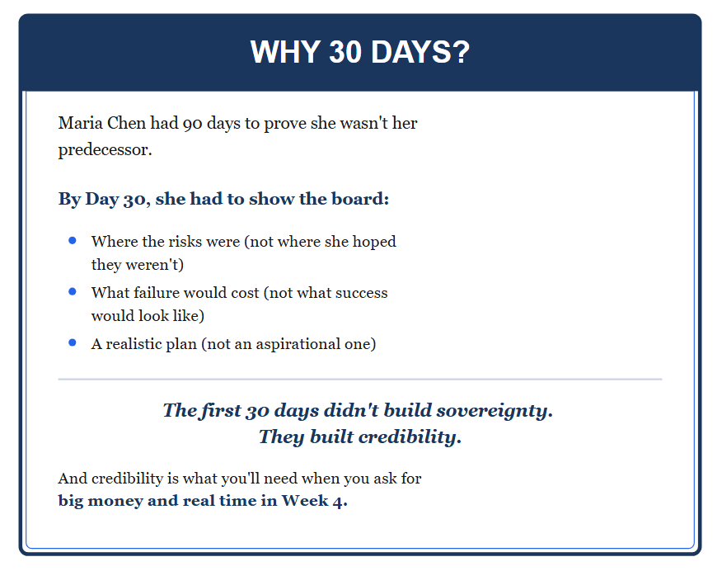
The same 30-day sequence Maria used before the dashboards, before the resilience tests, before the board learned to trust her. The difference between 'interesting ideas' and 'changed outcomes' is what you do in the thirty minutes after you finish this book.

Figure 44: The Sovereignty System (In One View)
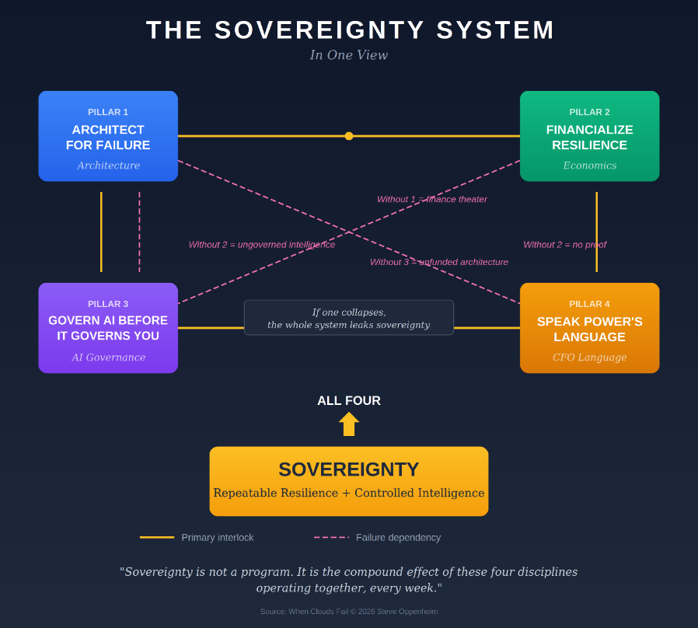
The complete four-pillar operating system: Pillar 1 (Architect for Failure) ↔ Pillar 2 (Financialize Resilience) ↔ Pillar 3 (Govern AI Before It Governs You) ↔ Pillar 4 (Speak Power's Language). If one collapses, the whole system leaks sovereignty. Sovereignty is the compound effect of these four disciplines operating together, every week.

"The crisis will come. The only question is whether you've already built the answer."
— Steven Oppenheim
Order the complete book on Amazon
whencloudsfail.opey.org
Available in Hardcover, Paperback, and eBook

